ASSIGNMENT 5

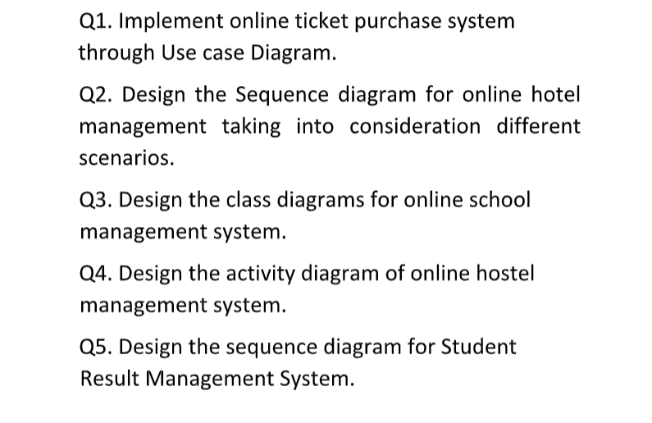

Q1. Implement online ticket purchase system

through Use case Diagram.

Solution

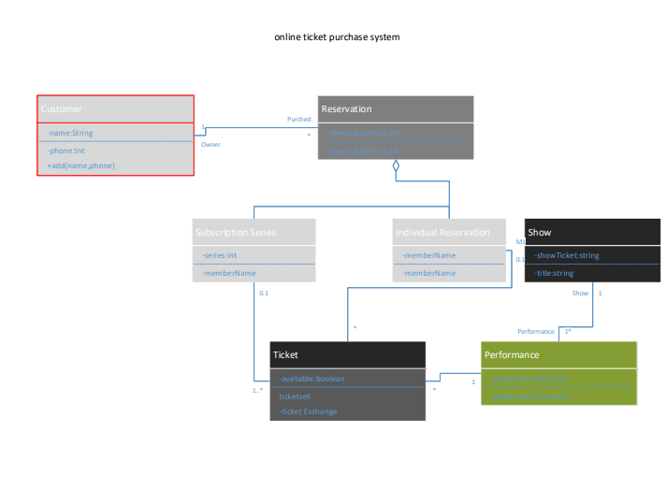

Q2. Design the Sequence diagram for online hotel

management taking into consideration different

scenarios.

Solution

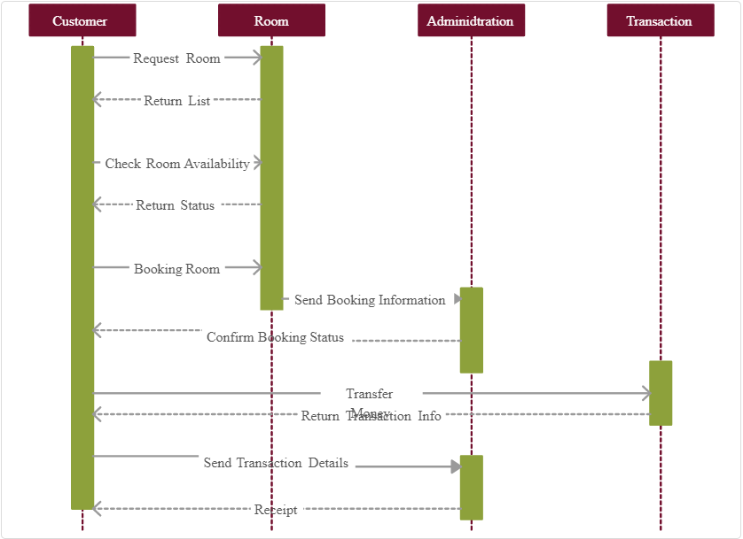

Q3. Design the class diagrams for online school

management system.

Solution

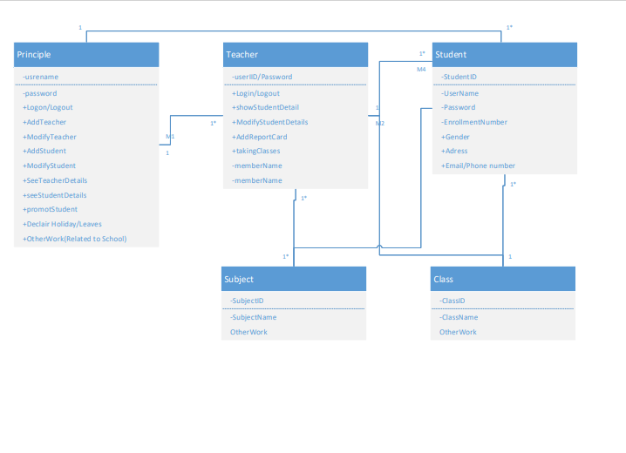

Q4. Design the activity diagram of online hostel

management system.

Solution

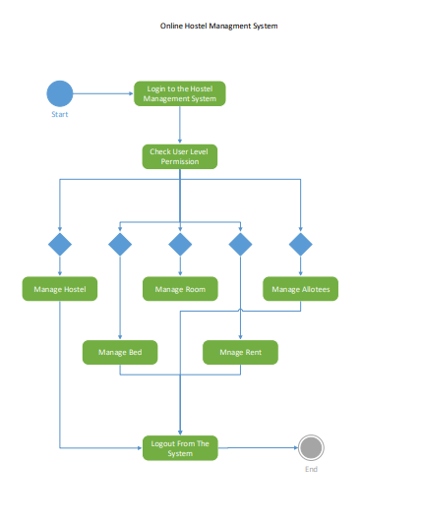

Q5. Design the sequence diagram for Student

Result Management System.

Solution

